MS SQL SERVER
Standard Operating Procedures
(SOP)
Verify all instances are running in SQL Server
Submitted to



BY



CIS, Wipro Limited

Document Details

Project Name | Innogy SE
Account | CIS
IT Component/Application Title | Verify all instances are running in SQL Server
Current Version | 1.5
List of Contributors | Pradipkumar Kansara, Kiran Bhalekar, Ayushi Gautam, Sivakumar Goud, Ayushi Srivastava
Customer Contact Information

Version History
(All revisions made to this document must be listed in chronological order. All revisions must be approved. Review and Approval can be done by an internal source or by the customer)
Version | Date of Revision | Description | Author | Reviewed By | Approved By
1.0 | 29-08-2015 | Initial Draft | Kiran Bhalekar | Pradipkumar Kansara | Mahesh Keshatwar
1.1 | 04-09-2015 | Document Completed | Kiran Bhalekar | Pradipkumar Kansara | Mahesh Keshatwar
1.2 | 21-08-2016 | Updated document to standard format | Kiran Bhalekar | Pradipkumar Kansara | Mahesh Keshatwar
1.3 | 17-05-2017 | Wipro and Innogy Logo changed | Ayushi Gautam | Pradipkumar Kansara | Mahesh Keshatwar
1.4 | 14-09-2017 | Updated document to Wipro Standard format with header and footer | Sivakumar Goud | Pradipkumar Kansara | Santosh Badiger
1.5 | 18-11-2018 | Updated the document | Ayushi Srivastava | Pradipkumar Kansara | Santosh Badiger

Document Distribution List
Sl. No. | Name and Company | Purpose
1 | RWEIT-SQLDBA | Document is useful for checking the instance status in SQL server.
2

TABLE OF CONTENT
1. Purpose 1
2. Scope 1
3. Verify All Instances Are Running In Sql Server 1
3.1 Verify All Instances Are Running In Sql Server In Sql Server 2000 1
3.2 Verify All Instances Are Running In Sql Server 2005 6
4 Reference 12

Purpose
This document is prepared for the management and troubleshooting of SQL Server Database Administration Services at <Customer Name>.

Scope
This document is prepared for GSMC Wipro sustenance team and provides the concepts of Verifying all Instances are running in SQL Server for the administration of the SQL Server database at <Cust Name>.

Verify All Instances Are Running In Sql Server

Verify all Instances are running In SQL Server in SQL Server 2000

To verify all Instances are running In SQL Server in SQL Server 2000 we require connecting the Database Server.

Step 1: Connect to the database server, go to

Start > Run


Step 2: Here type the command
mstsc /console

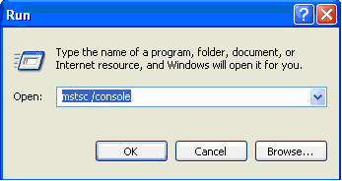

Step 3: Select the I.P. of the server to connect to.


Enter the Server Name Here

Enter the valid username and password to login to the database server.

Step 4: Open the service manager, go to Start > Microsoft SQL Server > Service Manager.

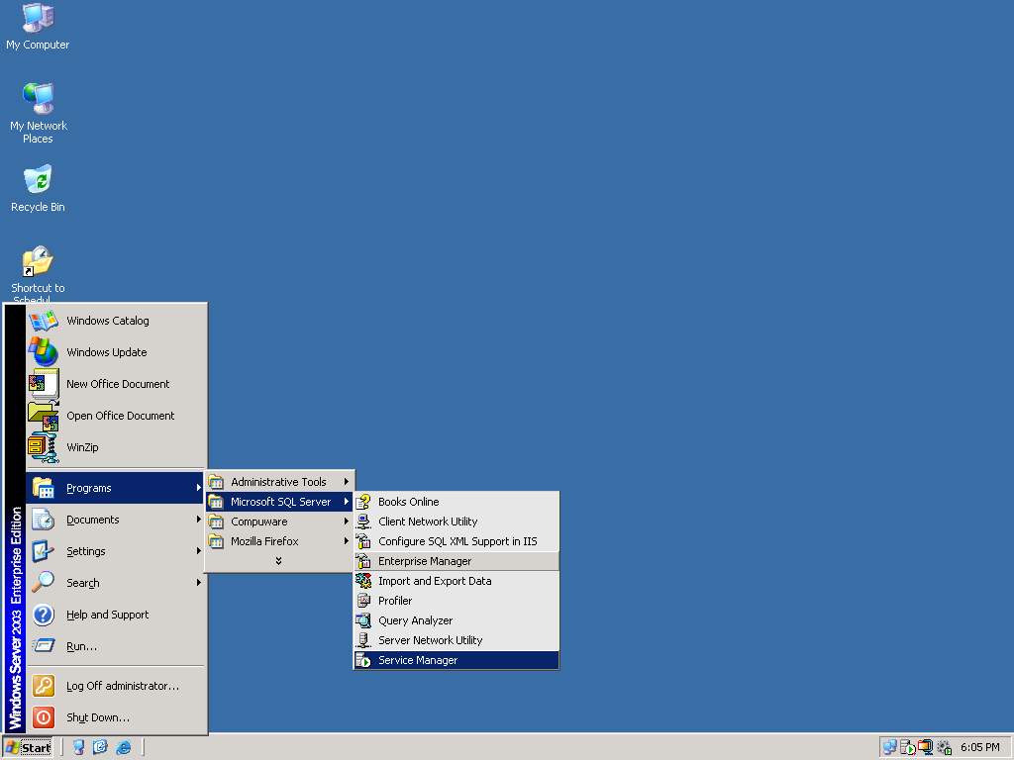

Step 5: Check the service is running. If the SQL Server is running I will be in green.

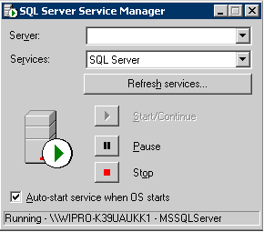
Enter the Server Name Here

Step 6: Go to Start → Run → services.msc → Then Press Enter
Check the below services are running or not.
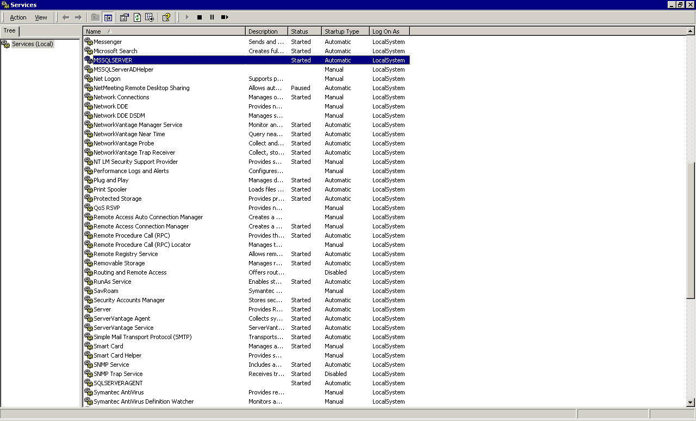

Step 7: Go to Enterprise Manager
Start → Programs → Microsoft SQL Server option → Select Enterprise Manager.
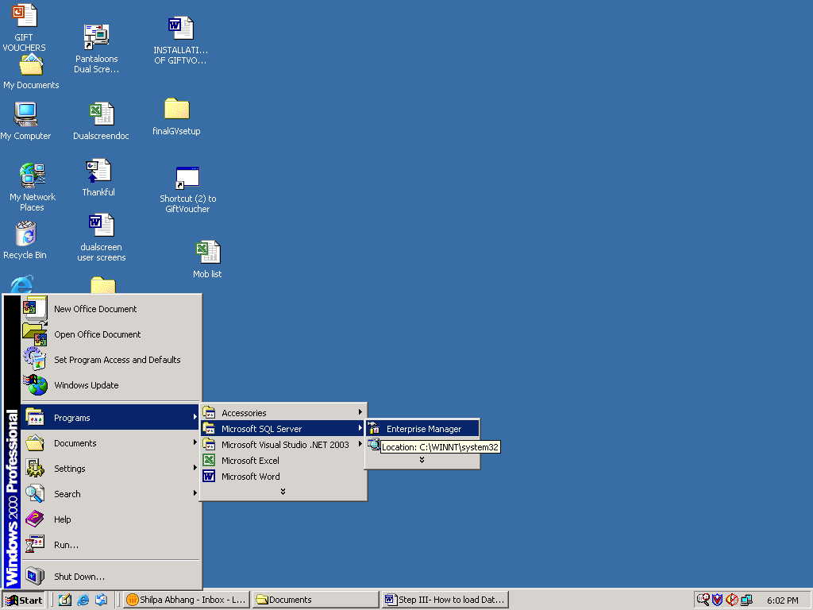
Step 8: Click on Databases and check the database status. If the status is normal it won’t show any thing against the database name.
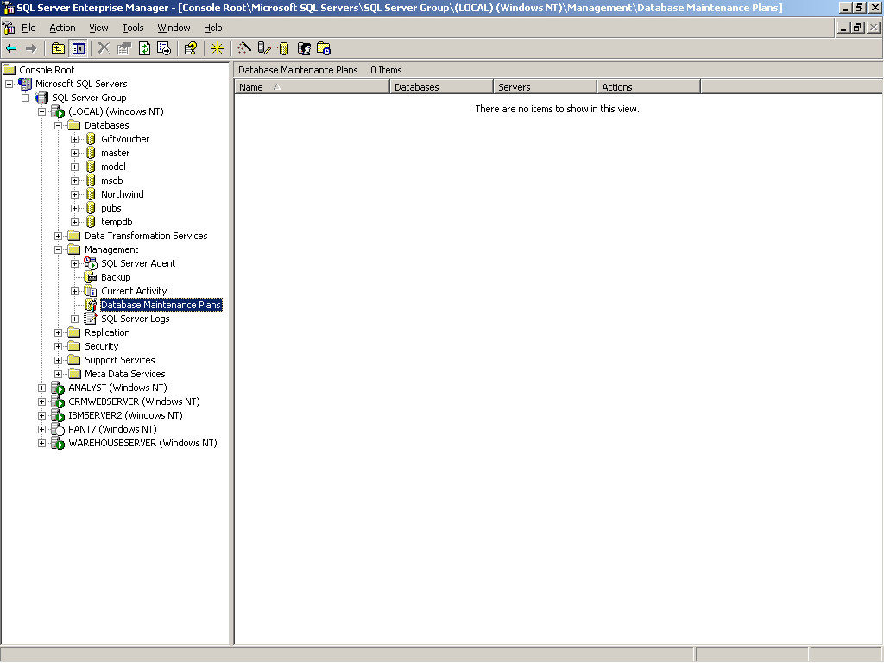

Verify all Instances are running in SQL Server 2005

Step 1: Connect to the database server, go to

Start > Run

Step 2: Here type the command
mstsc /console

Step 3: Select the I.P. of the server to connect to.

Enter the Server Name Here

Enter the valid username and password to login to the database server.

Step 4: To open the SQL Server Surface Area Configuration go to
Start > Programs > Microsoft SQL Server 2005 > Configuration Tools > SQL Server Surface Area Configuration
The SQL Server Surface Area Configuration will be displayed as follows:
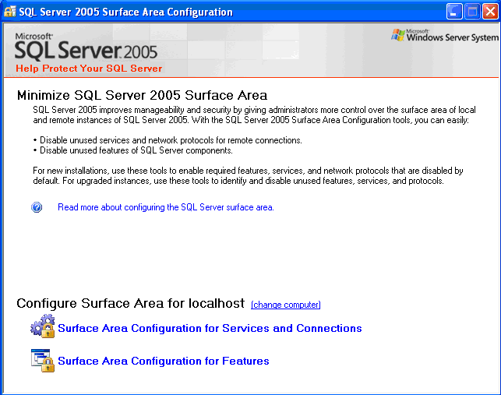
Now click on the Surface Area Configuration for Services and Connections
Step 5: Click on “Service”.
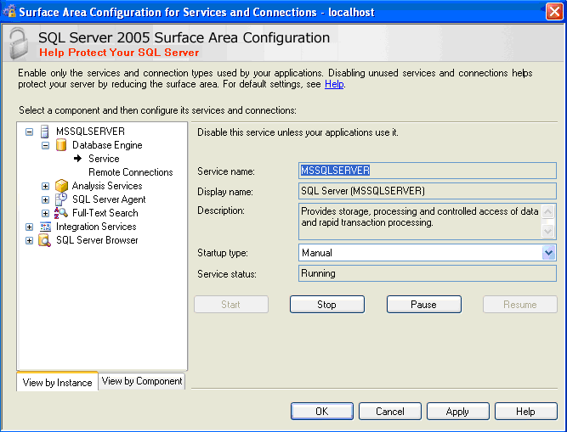

Step 6: Go to Start → Run → services.msc → Then Press Enter
Check the below services are running or not.

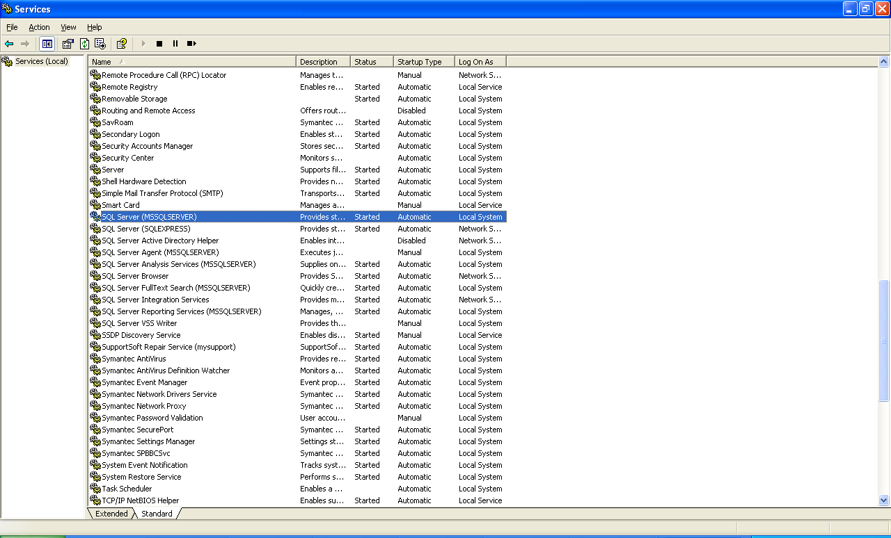
Note:
1While service is down; if we try to connect database will throw the following error.
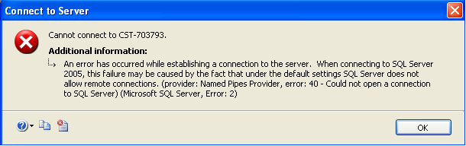

2. While the SQL Server Management Studio is opened and service gets down in the middle of any operation. Then the following error message will be displayed.

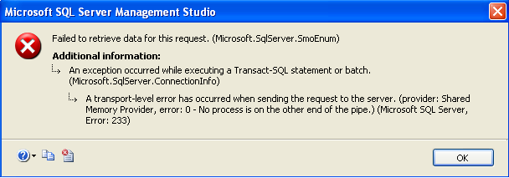

Step 7: Go to Start > Program > Microsoft SQL Server 2005 > SQL Server Management Studio to open the SQL Server Management Studio.

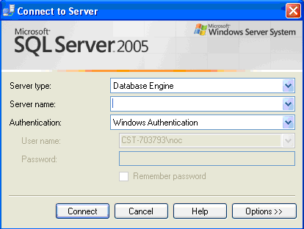
Enter the Server Name Here

Step 8: To connect do the following:
- Select Database Engine as “Server type”.
- Select the Server Name.
- Select the Authentication as “Windows Authentication”.

Then the SQL Server Management Studio Window will be displayed as follows:
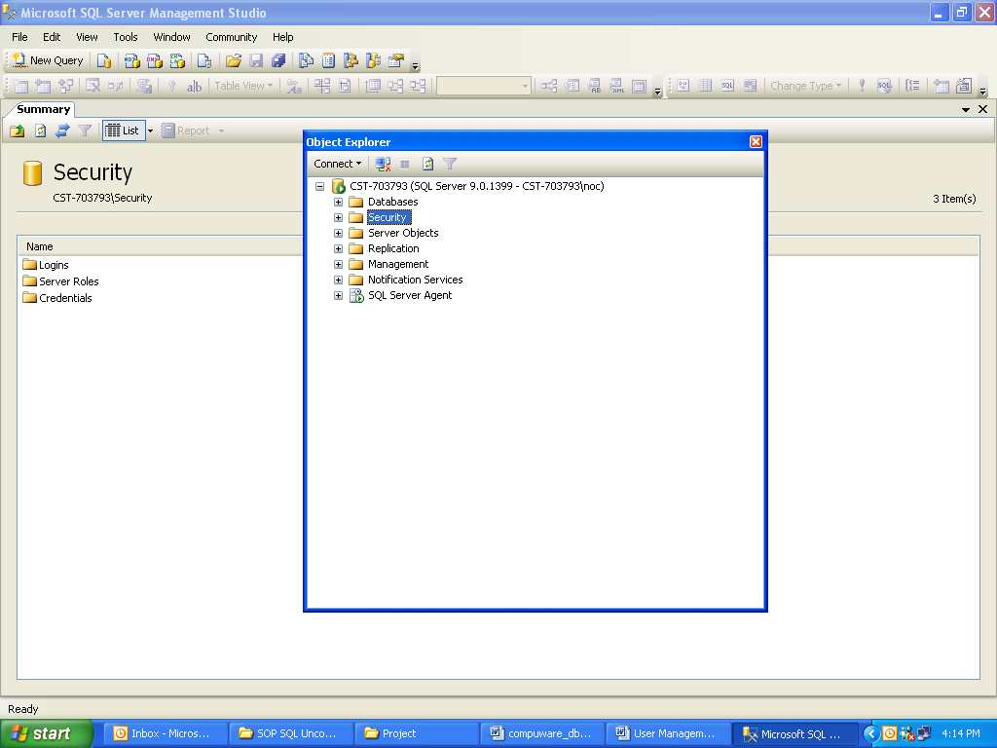

Step 9: Click on Databases and check the database status. If the status is normal it won’t show any thing against the database name.

4 Reference
For SQL Server 2000
- http://msdn2.microsoft.com/en-us/library/aa213801(SQL.80).aspx
- http://msdn2.microsoft.com/en-us/library/aa213792(SQL.80).aspx
- http://msdn2.microsoft.com/en-us/library/aa213792(SQL.80).aspx
For SQL Server 2005
- http://msdn2.microsoft.com/en-us/library/ms188980.aspx
- http://msdn2.microsoft.com/en-us/library/ms173748.aspx

